**An Empirical Study to Initiate a Reliable Scale About the Impact of Developing and Instructing Statistical Online Courses on Virtual Teaching**

**Said T. El Hajjar**

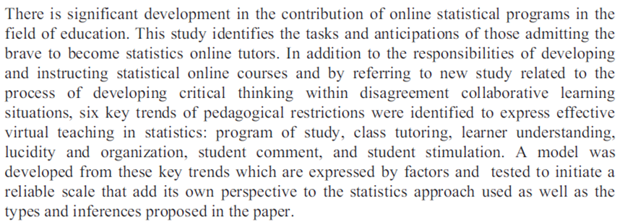**Abstract**